1. **Introduction**

229 promotes equality of opportunity for people with access needs and we are proud to work with Attitude is Everything. This guide is designed to inform everybody who comes to 229 what we can offer customers who may have specific requirements.

1. **Download Link (word)**

You can download all information on this page here.

1. **Venue Description**

**Venue 1: There is step free access into the foyer/box office through a set of double glass doors. After this, there are 24 steps (with handrail) down into the venue.**

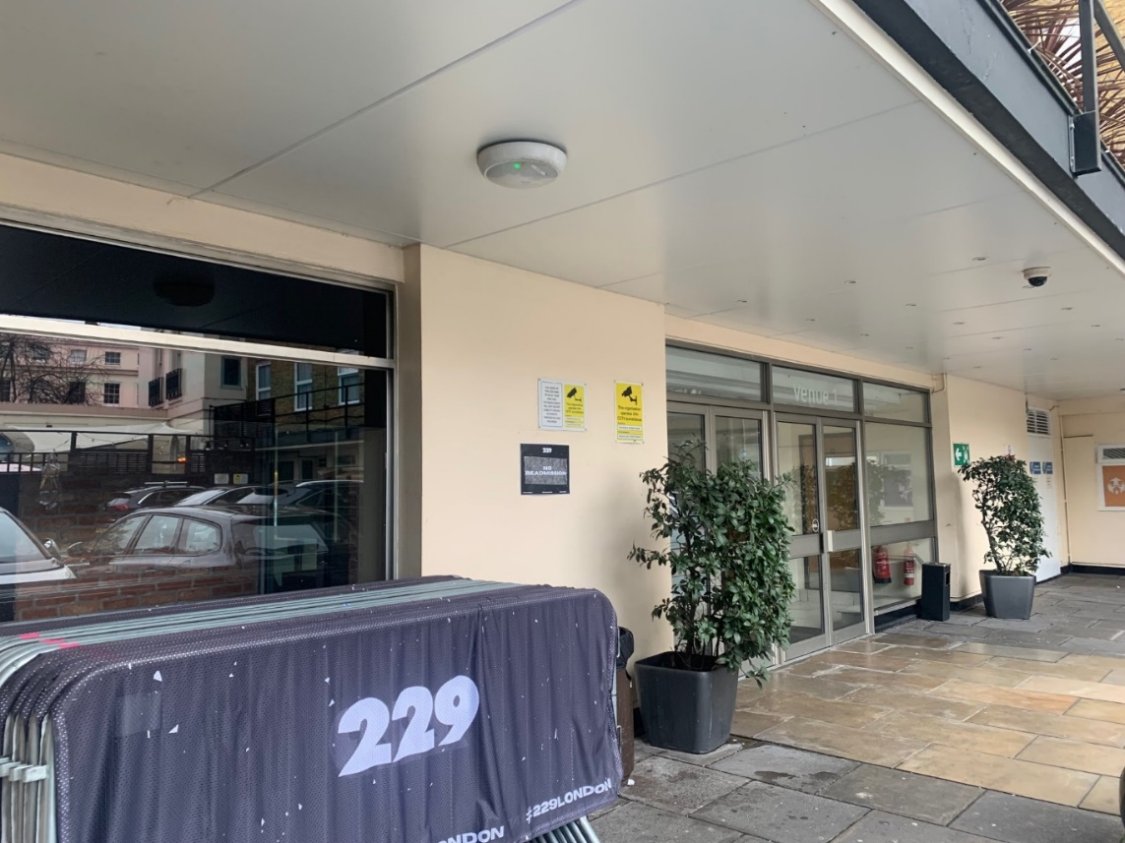

**Venue 2: Entrance to Venue 2 is through the canopied entrance on Great Portland Street. It leads straight to a flight of 24 stairs down into the venue.**

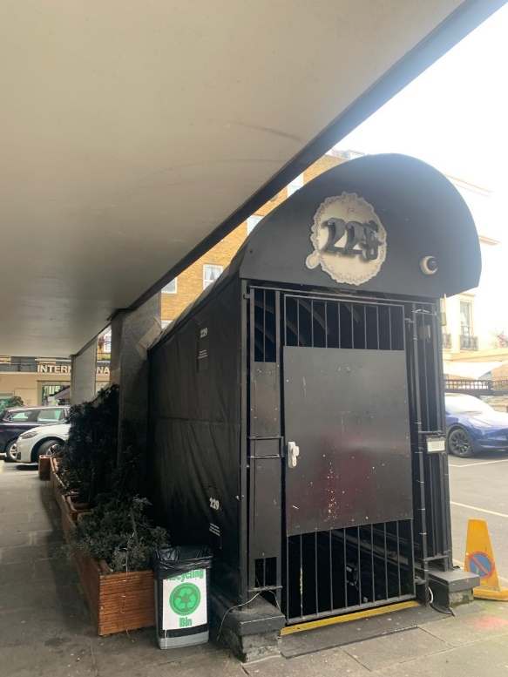

**Both venues are accessible via the lift – please see Section 7 for more information.**

1. **How To Apply**

**If you have accessibility requirements and wish to attend a show at 229, you will be able to purchase access tickets via our ticketing partner DICE. There will be a choice of ‘Accessibility – Ambulant’ and ‘Accessibility – Wheelchair’. Access tickets are only available through DICE, and we request that you do not buy a ticket with an alternate ticket seller as we are unable to ensure we receive access requests from other ticketing companies and want to avoid disappointment.**

For PA/Companion/Carer tickets, please contact DICE <https://dice.fm/contact> and choose the ‘Accessibility Request’ option and type the event you are requesting the accessibility ticket for into the ‘Event’ field. If you can’t find the event, type ‘229’ to bring up a listing of all our events. From there, type your request into the ‘Message’ field and DICE will respond to your request.

You may need to provide proof of eligibility. Suggested documents:

* Front page of DLA / PIP (no specific rate required)
* Front page of Attendance Allowance letter (no specific rate required)
* Evidence that registered severely sight impaired (blind)

**We have limited capacity to accommodate access customers and carer tickets, so if you have not made prior contact with DICE and we are already at capacity, you may be denied access. We offer authorised carers a complimentary ticket.**

If you have further queries, please email [info@229.london](mailto:info@229.london) – we are a small team but will endeavour to get back to you within 5 working days.

1. **Travel Guide**

**Address: 229 Great Portland Street, W1W 5PN**

**We have an easy tube and bus access to the venue:**

* **The Hammersmith & City/Circle and Metropolitan Lines go to Great Portland Street - 300 feet away from the venue.**
* **The Bakerloo Line stops at Regent's Park Station - 0.1 miles from the venue.**
* **The Victoria and Northern Lines stop at Warren Street - 0.4 miles away.**
* **There are plenty of direct buses from West and East London running along Euston Road plus buses running north to south, going down Great Portland Street and vice versa.**
* **Night Tube services now run on Victoria Line (Warren Street Station) and Central Line (Oxford Circus Station) on Fridays and Saturdays. There's an extensive night bus service operating nearby. Please check the TFL website if unsure.**

**We do not have any customer parking at the venue; however, there are many side streets around the venue, most of which offer free parking after 6:30 pm. We recommend Park Crescent and Outer Circle.**

1. **Blue Badge Parking**

**There are Blue Badge parking bays on Park Crescent and Greenwell Street. Both are approximately 100m from the venue. Please be aware that Greenwell Street is within the London CCZ, but Park Crescent is not (if approached from Euston Road).**

1. **Arrival Guide**

**Timings are specific to each show – please check your ticket to find this information. Generally, we are unable to share stage times but most shows open doors at 7pm and finish by 11pm. Clubs generally open around 10pm and finish between 2-3am. We endeavour to keep the ‘FAQ’ section of DICE show listings updated with which venue the show will be in.**

**Venue 1: We ask that any customers who are unable to use stairs speak to one of our members of security at the foyer/box office at Venue 1, who can call a staff member to lead them to our accessible lift that goes into the venue. Please have your ticket ready or be ready to give the name of the person who booked the tickets.**

**Venue 2: We ask that any customers who are unable to use stairs speak to one of our members of security on the door of the venue who will call a staff member to lead the customer to our accessible lift that goes into the venue. Please have your ticket ready or be ready to give the name of the person who booked the tickets.**

**If you require priority entry (queue jumping), please inform the security staff on the door of the venue.**

1. **Toilets & Bar**

**Venue 1: In the venue there is one accessible toilet at the bottom of the stairs by the bar, on the same level as the main viewing area. Regrettably there is not a lowered counter at the bar, but our friendly bar staff will be more than happy to help you.**

**Venue 2: In the venue there is one accessible toilet to the right hand of the stage, on the same level as the main viewing area. The corridor it is in is generally closed to avoid audience spill into incorrect venues, however our staff are happy to help and ensure you have access to this toilet during your visit. Regrettably there is not a lowered counter at the bar, but our friendly bar staff will be more than happy to help you.**

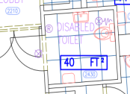

**We also have a public bar (The Thirsty Scholar) on the ground level with an accessible toilet near the smoking area. Please speak to a member of staff and they will direct you there.**

1. **Inside 229**

We do not have a designated viewing area. In Venue 1, the stage is high and therefore viewing is good and there are great sight lines to the stage from any position in the venue. Venue 2 is an intimate space where it’s possible for access customers to sit within good proximity/view of the stage. The member of staff who shows you into the venue will show you a recommended area to view the show from.

1. **Assistance Dogs**

**We kindly ask that you inform us in advance and provide proof that your dog is registered with an organisation that is a member of Assistance Dogs UK.**

1. **Strobe Lighting**

**We use haze, strobe, flashing lights and other theatrical effects in the venue. If you need further information about this, please email** [info@229.london](mailto:info@229.london) **regarding the specific show. Please note that this may not be immediate as we may need to contact the promoter to get more information.**

1. **Evacuation Policy**

All our security, stewards and porters are trained to know how to assist customers with access needs in case of emergency. We ask that anyone who is unable to use stairs returns to the lift lobby area with their carer, where they will be assisted and lifted up to ground floor level or alternatively directed to a designated Safe Area.

1. **Smoking**

The smoking area is on the ground floor at the main entrance. If a person with access needs or using a wheelchair wants to go outside to smoke, please notify a member of security or other staff member and arrangements will be made to use the lift.

1. **No Readmission**

We operate a No Readmission policy once you have left the venue. Please speak to staff if you need to leave and later return due to access needs.